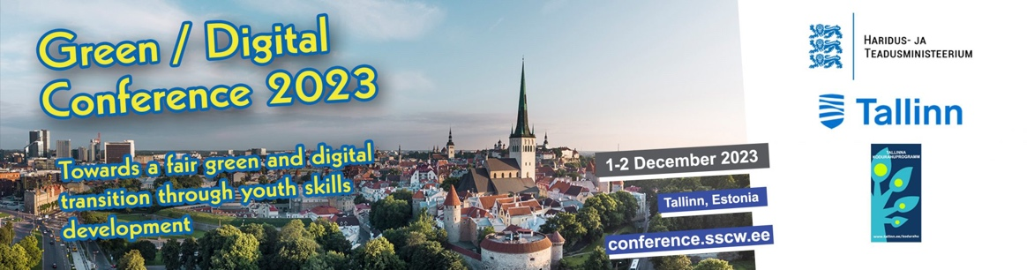
Tallinn Declaration on fair green and digital transition.
We, the participants in the conference in Tallinn on December 1th and 2nd 2023, have discussed the theme of “TOWARDS A FAIR GREEN AND DIGITAL TRANSITION THROUGH YOUTH SKILLS DEVELOPMENT“. Based on the deliberations, we issue the following declaration:
- Climate change represents the highest priority for youth as it conditions its future and that of coming generations. It should receive the utmost consideration from all policy makers and local, regional and central authorities.
- Governments are called upon to introduce all necessary measures to enhance environment protection and reduce reliance on all polluting elements be they in agriculture, industry, bureaucratic activities and city management.
- Governments are required to create the necessary space for youth to participate in the design and development of digital tools and educational materials. This space will also allow youth to express their views and present their vision about the issue of climate change and environment protection in an inclusive approach which will take into account the notion of sustainability and the balance between technological advances and human dimension in society.
- Digitalisation is considered as an essential tool to facilitate the energy transition process but it must take into account the importance of the necessary proper digital education, social acceptability by local communities, personal data protection requirements and cyber security (in all its dimensions, ie, hacking, scamming, cyber bullying, discrimination, etc.) to insure the reliability and sovereignty over the system.
- In this process civil society particularly youth have a major role to play, to advocate, initiate, facilitate and participate in the technological shift as it requires a change of mindset and a new social organization and even a new concept in the social contract between citizens and government; and for businesses a new entrepreneurial model based on the balance between responsible use of technology and an environmentally-friendly business organization.
- Given the importance of the issue and its impact on our lives as a society we call on governments and civil society organisations to cooperate as closely as possible to device the new regulations and laws if needed, so as concerns and interests of all stakeholders are taken into account for the benefit of all.
- We also call on all governments to reach out to the international community within the EU and beyond to enlist its support and commitment to the challenges of green and digital transition and climate change in a more cooperative spirit and a win-win approach.
Done in Tallinn on December 2nd, 2023

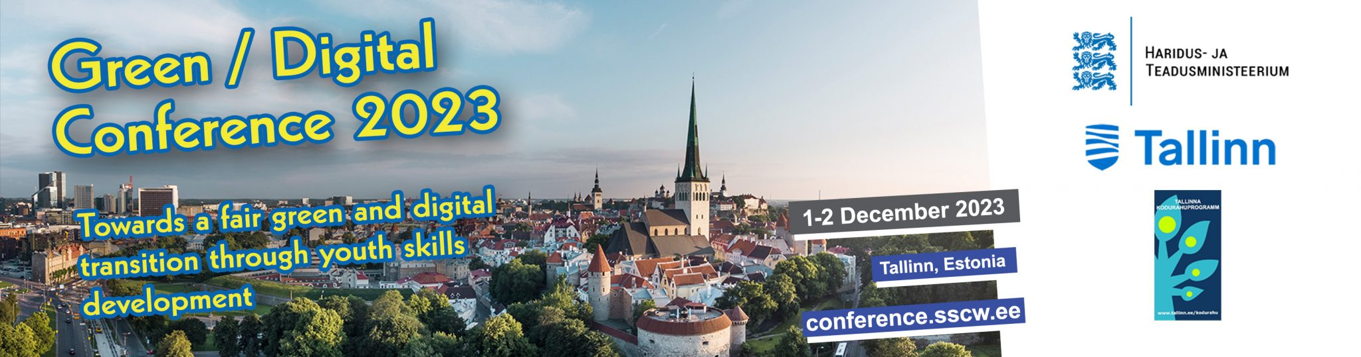
For more information visit: https://conference.sscw.ee/

